Boston Community Capital

The Ideas That Inform Our Vision and Strategy

Excerpt from Comprehensive Business Plan

January 1999

A. Our Definition of Healthy Communities
Since Boston Community Capital uses the tools of financial intermediation to build healthy communities, we begin with a definition of healthy communities.

Boston Community Capital defines healthy communities by:
- the connectedness that people feel to their community,
- the degree to which community assets and infrastructure are present and functioning, and
- how well those communities are linked to regional, national and global economies.

1. Connectedness to Community: The attributes that cause individuals to feel connected to their community create a matrix that transforms individual resources, or isolated individuals, into a civic society. Those attributes reflect the health of a community and are often the basis for the choices individuals make about where to live, work and invest. Those attributes include:
- Opportunity - healthy communities offer a range of choices and opportunities (for careers, recreation, education, and housing). Individuals feel confident and optimistic about their community and its future.
- Destination - healthy communities are a positive destination for residents and businesses. When communities are healthy, the decision to move, work, or invest there is made freely and is a positive decision.
- Diversity - healthy communities respect and welcome diversity.
- Dynamism - healthy communities change to accommodate the impacts of larger demographic or market changes. Healthy communities are rarely static or insulated, nor do they face rapid changes imposed from outside the community, such as speculation and gentrification, or disinvestment and abandonment.
- Investment - healthy communities attract investment because their residents, homeowners, and businesses expect their investment to have a positive return. This includes both financial investment (fixing up a storefront will bring in new customers) and time investment (organizing a crime watch will make the neighborhood safer).
- Information - healthy communities have a series of formal and informal overlapping networks and institutions which allow people to work together, identify and resolve problems, and share information quickly and accurately.
- Leadership - healthy communities have leaders who contribute to the well-being of the entire community, who are recognized throughout the community, who are role models, and who are recognized by non-community members as key participants when the community negotiates for governmental investment and the like.
- Participation - healthy communities encourage civic, public and electoral participation in matters of general concern. In a healthy community people vote, know the elected and civic officials who serve locally and, to the extent they choose, can be effective participants in local, state and national issues.

2. Community Assets and Infrastructure: In defining healthy communities, Boston Community Capital focuses on three measures of assets and infrastructure: (1) the physical; (2) those that create income and value; and (3) those that support cultural, community and support services.

Measures of Physical Assets and Infrastructure
- The availability and cost of good housing for all residents (including those with special needs),
- The availability, maintenance, and visual quality of the environment,
- The maintenance of existing investments in housing and commercial space,
- The availability, and maintenance of public infrastructure, such as transportation, civic buildings, and community facilities.

Measures of Income, Financial Assets, and Value
- Comparative levels of employment, unemployment and wages,
- Comparative levels of dependence on public assistance for housing and income,
- Trends and pricing in the real estate market,
- Comparative levels and trends of financial assets (net worth) in communities, businesses, and families.

Measures of Cultural, Community, and Support Services
- The level of crime and the perception of safety and comfort in a community,
- The level of educational achievement and the availability of appropriate educational services,
- The level, availability and affordability of health care and social and cultural services,
- The availability of community facilities and the level of civic events.

Each of the above is an indicator of real resources and assets available or needed to build a community. Policies and programs are often established to address deficiencies in these critical needs. Boston Community Capital’s investments are used to support, create or expand these assets.

3. Linkages to regional, national and global economies: Finally, Boston Community Capital defines a community’s health by its links to the larger regional, national and global economies. Educational resources, sources and markets for goods and services, and access to capital, among other things, are all key components for community growth and sustainability and are all primarily available through linkages to the broader economy. In our view, communities do not thrive in isolation without the resources, skills, opportunities, and discipline of the outside world.

Effective institutions, or intermediaries, are critical vehicles for connecting communities and the broader economy. Informed local institutions can accurately reflect and represent community interests and values. They can create a collective strength or market demand to attract better and cheaper goods and services. Conversely, institutions make it easier for external resources to identify and meet the needs and opportunities in local markets. In many low-income communities and for many low-income people, effective institutions do not exist. Therefore, these communities and people remain isolated from the mainstream economy.

B. The Role and Attributes of an Effective Community Development Financial Intermediary that Connects Sources and Uses of Capital
Boston Community Capital is one of the effective, institutional vehicles that builds healthy communities. As a financial intermediary that links low-income communities and broader capital markets, Boston Community Capital meets the capital and finance needs of low-income communities and individuals by:
- providing a range of existing financial vehicles, services and products;
- creating innovative financial vehicles, services and products to meet existing or new capital gaps; and
- participating in the creation of a national CDFI system.

Put another way, Boston Community Capital acts as an investment banker for low-income communities.

Boston Community Capital focuses its efforts on low-income people and the communities in which they live and work. However, to be an effective financial intermediary, Boston Community Capital must satisfy both users and sources of capital. Boston Community Capital’s constituents include the set of community-based institutions and businesses that provide goods and services for low-income people (e.g., community development corporations, social service agencies, small businesses and entrepreneurs, and housing cooperatives) and owners and managers of mission-driven, regulatory and commercial capital that invest in social and community ventures (e.g., banks, insurance companies, individual investors, socially-responsible mutual funds and religious organizations).

The chart below illustrates the sources of capital and the users of capital that Boston Community Capital serves.

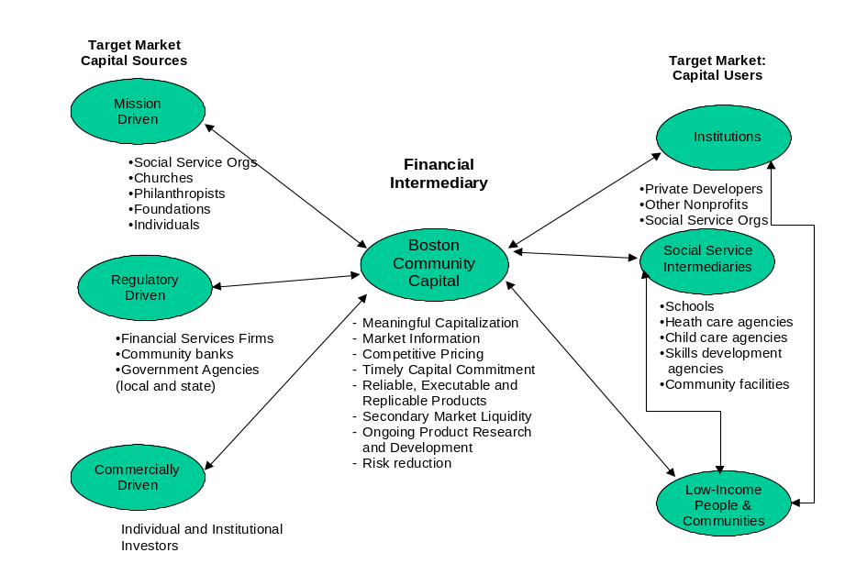

To be effective, community development financial intermediaries must have at least the following attributes:
- Meaningful capitalization - The intermediary must work at a scale that is appropriate for the needs of both the sources and users of capital.
- Market information - The intermediary must know and easily translate the risks, costs, and social impacts of the project, and the requirements, reporting needs and motivations of the investor.
- Linkages - The intermediary must stand at the intersection of capital markets and low-income communities as an entity that structures transactions, provides capital and financial services, and facilitates connections between users of capital and the capital markets.
- Competitive pricing - The overall cost of working through the intermediary must be lower than the cost of accomplishing the transaction directly.
- Timely capital commitment - Transactions must be accomplished within the reasonable timing expectations of the clients.
- Reliable, executable and replicable products - The intermediary must translate one-time, unique, or non-conforming transactions into transactions that are increasingly efficient and inexpensive to recreate.
- Secondary market liquidity - The intermediary must be able to access secondary capital markets by aggregating individual, often unique, transactions into replicable financial instruments that have characteristics recognized and accepted beyond the immediate partners in the transaction.
- Ongoing product and market research and development - The intermediary must be able to effectively innovate so that it can keep pace with the changing needs of its clients and markets.

